**Mr. Visca’s: Calculus (Chpt 2.3)**

**Chpt 2 – Day 8 Composite & Int Val Thm**

**Properties of Continuous Functions:**

If the function f and g are continuous at x = c, then the following combinations are continuous at x = c:

Sum

Difference

Products

Constant Multiple

Quotients

**Composite of Continuous Functions:**

If f is continuous at c and g is continuous at f(c), then the composite of _______ is continuous at c.

(If you have 2 continuous functions, their composite is also continuous)

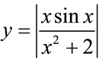

Show that the following function is continuous:

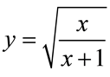

Show that the following function is continuous:

**Intermediate Value Theorem for Continuous Functions:**

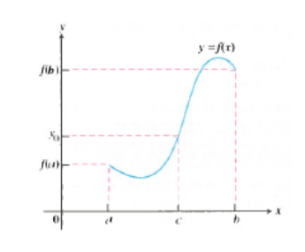If f(x) is continuous on some closed interval from [a,b], then for any point on that interval, c, there is a value,______________________________

Is there any real number exactly 1 less than its cube? Compute any such value accurate to three decimal places.

Is there any real number exactly 2 more than its cube? Compute any such value accurate to three decimal places.

*HW: sec 2.3*

*#s 19-39 odds only, 45*